# CLCA Monthly Meeting October 2, 2023

Call to order.

President Shauna Scheeman called the meeting to order at 6:30 pm. This meeting was held in person at Folsom borough hall. Everyone was asked to rise and recite The Pledge of Allegiance.

Roll Call of Officers

Secretary Henry Burhenne addressed the roll call with the following members being president.

Shauna Schneeman; President

Donna Sutts; Vice President

Nell Woulfe; Second Vice President

George Prottopappas; Treasurer

AnnaMarie Larocca; Secretary to the Treasurer

Henry Burhenne; Secretary

Marie King; Tier 3 Board Member

Reading of August Meeting minute

Henry Burhenne read the September meeting minutes. Donna stated we need to add the residents questions to the minutes

A motion to approve them was made by Annamarie to accept the minutes and add the questions to the approved minutes. And all were in favor.

Dams report

Beth Grasso gave her report.

Beth stated Zeuli is finishing work on the East Collings side spillway and continuing work on the north side spillway. Work is scheduled to be completed in Late-November.

Beth gave updates on Lake George and Lake Albert.

Nell asked if these dams were not necessarily needed we could save a lot of money.

Beth stated Lake George Dam is in terrible condition.

Nell asked what would be the impact if we did nothing?

Beth stated it is up to the CLCA to decide.

Beth stated she could look into having the lakes less than 5” in depth and they could be reclassified.

Annamarie asked about Lake Albert dam.

Beth stated the spillway may be able to be saved but we would probably have to add an auxiliary spillway,

Donna stated we have a court order to repair or replace all 4 dams.

Donna also stated we need to design that there is public access to these 2 lakes.

Beth stated we will have to bring up to current dam safety specifications.

It was asked how long it will take before the water can be raised in Cushman Lake once construction is completed?

Beth stated the state could take up to 2 months for approval.

Accounts receivable reports

Annamarie read the accounts receivable report.

George made a motion to approve. All were in favor.

Treasurer’s Report

George read his Treasurers report with account balances listed in these minutes.

Expenses:

RD Zeuli $51,550.50

RD Zeuli $154,715.11

Jersey Greentree $17,800

Hill Wallack $1,700.25

Hill Wallack $5,870.75

H&S business partners $8,916.88

Checkmate services $32.75

Dennis Lassaso plumbing $150

RAC $175

The Lifegaurd company $1,092.00

Liberty Bell bank $750

Intuit $200

Henry made a motion to approve the reading of bills for approval.

All were in favor.

Account Balances as of 9-30-23

Liberty Bell checking $209,737.84.

Liberty Bell Dams $750,475.18

Liberty Bell money market $80,801.26

Liberty Bell petty cash $1,065.90

Liberty Bell games of chance $4,812.05

Henry made a motion to approve the account balance report.

All were in favor.

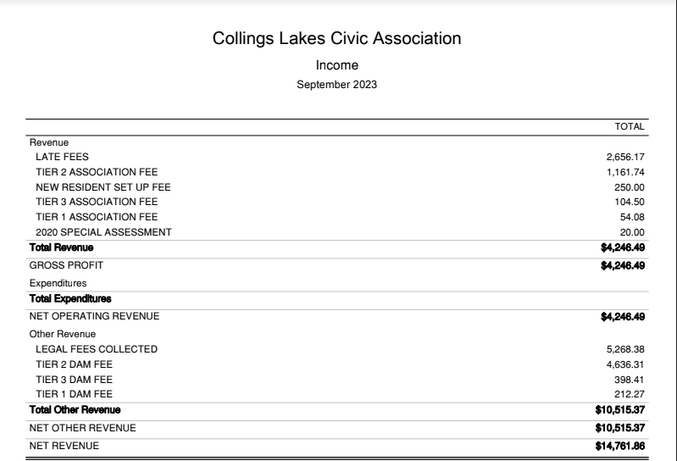

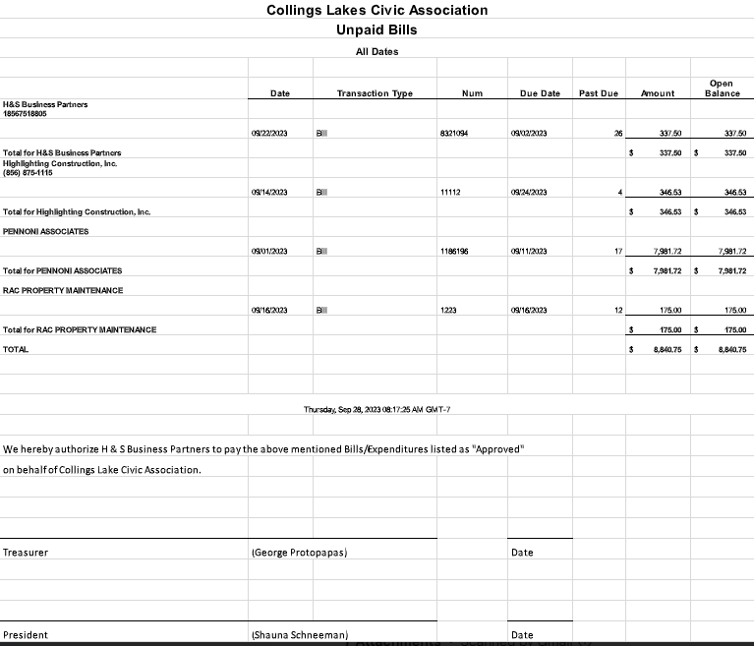

Annamarie made a motion to approve the unpaid bills for approval. All were in favor.

Grounds committee

Highlighting Construction completed with their work on the basketball courts and first beach.

First beach benches at basketball court and by the swings were rebuilt and painted.

Still need to replace swing at first beach.

Annamarie talked about Northland airboats; they will be presenting to clear trees from Cushman Lake.

Fund Raising

Next event is Harvest fest in October. Sunday October 8, 2023 10:00am to 3:00 pm

Looking for food vendors and craft vendors.

We will be selling mums.

Raffel

50/50 tickets available

Live band 1:00 pm to 3:00 pm

Tee shirt fundraiser has raised $197

Officially opening free library / Ribbon cutting

Election committee

Donna stated we must follow Radburn rules.

Donna asked for permission to contact Greg Shivers to ask about ballots being anonymous.

Tier 1

Nell Woulfe

Steve Slimm

Tier 2

Shane Backer

Diane Rhodes

Carole Weldon

Tier 3

Don Saunders

At Large

Lynn venial

Annamarie LaRocca

George made a motion for Donna to email Greg to ask questions and to pay for Greg’s time.

Roll call vote.

All were in favor.

President’s report

Committee night will be next Monday.

Trustee Report

George- nothing

Donna -nothing

Nell – nothing

Annamarie – nothing

Henry - nothing

Marie – nothing

Open Floor

Resident asked Nell about her statement about lowering lake George.

Nell stated she did not say she wanted the lakes lowered.

Resident said do not even look at the option of lowering the lake.

Another resident stated in a chat she has not heard anything about the welcome committee.

Nell stated she is working on it.

Another resident asked for clarification on the $750 charge from Liberty Bell bank for inspection to use the loan.

Nell stated this is normal for a construction loan.

Shauna stated this money actually goes to a engineering company to perform the inspection.

Resident asked how much H&S charged to redo the nomination forms the second time?

George stated that amount was $1038.13

Resident asked how much we paid to run an add for Harvest fest in the Hammonton Gazette?

Annamarie stated the money was donated to pay for the add.

Adjournment

Annamarie made a motion to Adjourn the meeting at 7:55pm. All were in favor.

Next meeting will be 11-6-2023 at 6:30 pm via ZOOM.