# CLCA Monthly Meeting November 6, 2023

Call to order.

President Shauna Scheeman was absent so Vice President Donna Sutts ran the meeting. This meeting was held in person at Folsom borough hall. Everyone was asked to rise and recite The Pledge of Allegiance.

Roll Call of Officers

Secretary Henry Burhenne addressed the roll call with the following members being president. 1 board member was absent,

Shauna Schneeman; President - Absent

Donna Sutts; Vice President

Nell Woulfe; Second Vice President

George Prottopappas; Treasurer

AnnaMarie Larocca; Secretary to the Treasurer

Henry Burhenne; Secretary

Marie King; Tier 3 Board Member

Reading of October Meeting minute

Henry Burhenne read the Octobert meeting minutes.

A motion to approve them was made by AnnaMarie and all were in favor.

Dams report

Leeron from Northland Airboats introduced his company to residents and explained how they operate and what their expenses are. They are used on marshlands and lakes to navigate in places most contractors cannot. We will have to do a drone video to identify which trees need to come down to get a firm quote. No decisions have been made.

A resident questioned the exact location of trees to be taken down. No decision has been made.

The question was raised whether a permit will be needed. AnnaMarie has contacted the DEP but does not have an answer yet. AnnaMarie provided them with the permit number in place for the dam work to see if this could be used for tree work and explained all trees had a diameter of less than 4”.

Residents questioned the square footage of trees to be removed. This will be determined by the drone footage.

A question was asked about which account would pay for tree removal. Previous board member stated he thought dam money could only be used for dam construction. Calls will be made to clarify this.

No further Questions were asked.

Accounts receivable reports

Annamarie read the accounts receivable report.

George made a motion to approve. All were in favor.

Treasurer’s Report

George read his Treasurers report with account balances listed in these minutes.

Expenses:

Henry made a motion to approve the reading of bills for approval.

All were in favor.

Account Balances

Liberty Bell checking $241,732.13

Liberty Bell Dams $751,092.01

Liberty Bell money market $80,867.68

Liberty Bell petty cash $849.87

Liberty Bell games of chance $4246.05

AnnaMarie made a motion to approve the account balance report.

All were in favor.

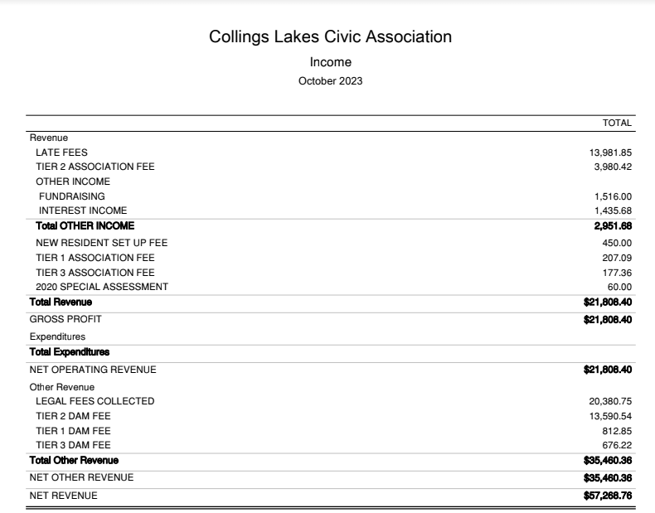

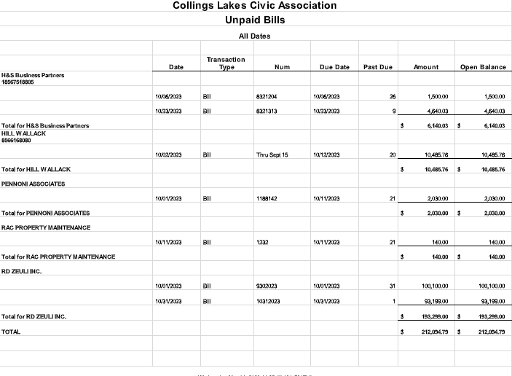

Grounds committee

More leaves will need to be cleaned up.

Discussion on purchasing for beaches 2 & 3 for next year.

Fund Raising

AnnaMarie stated Harvest fest made $1134.00 profit and the 50/50 is up to $630.

Next event is a possible tree lighting maybe December 10th.

Welcome committee.

Nell stated she needs an updated list.

Election committee

Ballot deadline is November 22,2023.

Round robin of perspective candidates.

Trustee e Report

George- nothing

Donna -nothing

Nell – nothing

Annamarie – nothing

Henry - othing

Marie - Nothing

Adjournment

Annamarie made a motion to Adjourn the meeting at. 7:34pm. All were in favor.

Next meeting will be 12-4-2023 at 6:30 pm in person at Folsom borough hall. Election ballots will be counted at this meeting.